**Installation and Upgrade**

**P3 – Plan an installation**

For this assignment I will be installing Rainmeter, free desktop-customization software that allows users to add various widgets to their desktop, for monitoring resource usage, playing music, or adding shortcuts.

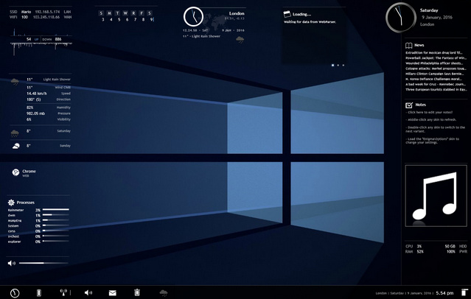

An example of a desktop using Rainmeter.

I will install the software, set it up with the default widgets, then upgrade it by downloading a custom a skin and applying that.

**Installation**First, I download the .exe file from Rainmeter’s website:

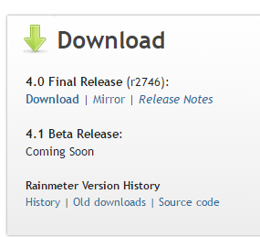

When opened the following dialog appears:

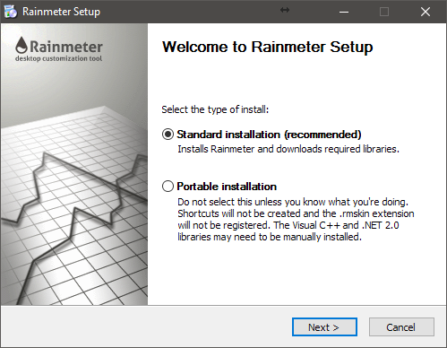

I went with the standard installation as I was not running Rainmeter portably. I also used the default options on the next part of the installer.

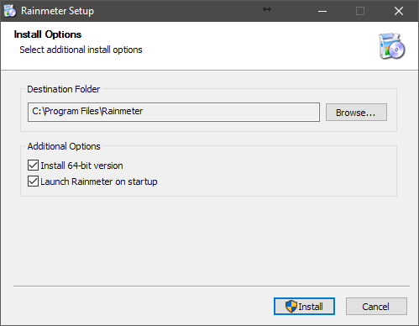

After clicking install, the install the installation happened automatically and Rainmeter launched itself with the default skin.

**P5 - upgrade**

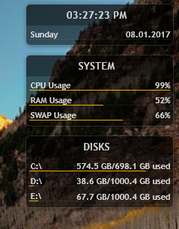However, Rainmeter is fully customisable. It is possible to make your own skins in addition to the handful that come with it, so I decided to download one.

I found VisBubble, a music visualizer.

It came with an installer, then I simply added it to the desktop. It worked straight away without any setup. Now Rainmeter has extra functionality.

**P6 – Importance of User Acceptance**

User Acceptance is the process software goes through before being fully released to the public. It is like open beta testing.

Essentially, new software is released, and information on user’s opinions is collected. This could be through telemetry or surveys. All use of the software is considered, from installation to the reasons for uninstalling the software.  
This information is collated and used to fix issues for future releases. For example, telemetry may reveal that the software is unstable with certain hardware, or that users struggle to find the menu. These issues can then be fixed in an update.

**M3 – Backing up**

Sometimes upgrading software can corrupt it or lose data and settings. Therefore, it is important to make a backup of the software, data or settings so that if something goes wrong they can be recovered. There are a few ways of doing this;

* Back up user data. This includes files and projects they are working on with the application. That way, if the application is compromised, the work will not be.
* Back up settings. This could be by making a copy of the config file, or simply taking note of settings and changing them back later.
* Copying the entire application. This is the easiest method for some small non-proprietary applications. If something goes wrong during the upgrade then the copy can be restored.

**M4 – Cancelling**

Almost all installers have multiple cancel options. For many, this involves a multi-stage setup procedure with cancel or back buttons at each stage, and some applications also allow the installation process itself to be cancelled.

**D1 – Justifying an Installation**

I installed Rainmeter because I consider it to be useful software – it allows me to easily monitor my system usage, and add visually appealing widgets to the desktop. It uses few system resources.